Eat My Apples

Sceanrio

The player is the asterisk (*) and must “eat” all of the apples (O).
A stopwatch starts when the program loads and stops when the user hits the Escape key.
The Player moves using the arrow keys (up, down, left, right)
The time taken in seconds is displayed after the escape key is pressed.

The screen
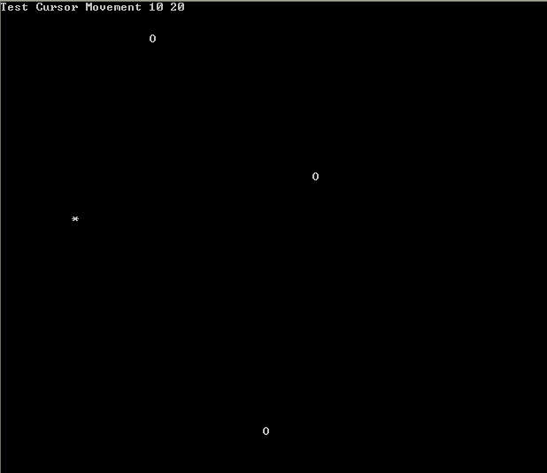

Player *

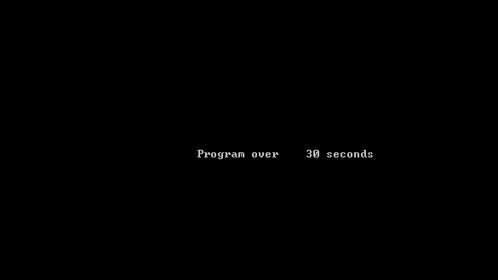

The Program Code

Module Module1

Sub Main()
Dim move As ConsoleKeyInfo 'move hold the key pressed by the user
Dim xpos, ypos As Integer 'Screen positions x (horizontal) y (virtical)
xpos = 10
ypos = 20
Dim Watch As Stopwatch = Stopwatch.StartNew 'Start the stopwatch
Console.CursorVisible = False 'Turn off the cursor

Console.Clear()

PlaceFood() 'Place food randomly on screen (see procedure)

Do
Console.SetCursorPosition(0, 0)
Console.WriteLine("Test Cursor Movement {0} {1}", xpos, ypos)
'Place Star at position on screen –changes after each -keypress(see below)
Console.SetCursorPosition(xpos, ypos)
Console.Write("*")

move = Console.ReadKey() 'get user keypress

Select Case move.Key
Case Is = ConsoleKey.RightArrow 'user pressed Right Arrow Key
If xpos + 1 < 80 Then 'stay on screen
Console.SetCursorPosition(xpos, ypos) 'erase current position
Console.Write(" ")
xpos = xpos + 1 'set new position
End If
Case Is = ConsoleKey.LeftArrow
If xpos - 1 > 0 Then
Console.SetCursorPosition(xpos, ypos)
Console.Write(" ")
xpos = xpos - 1
End If
Case Is = ConsoleKey.UpArrow
If ypos - 1 > 0 Then
Console.SetCursorPosition(xpos, ypos)
Console.Write(" ")
ypos = ypos - 1
End If
Case Is = ConsoleKey.DownArrow
If ypos + 1 < 50 Then
Console.SetCursorPosition(xpos, ypos)
Console.Write(" ")
ypos = ypos + 1
End If
End Select
Loop While move.Key <> ConsoleKey.Escape

Watch.Stop() 'stop the stopwatch

Console.SetCursorPosition(34, 25) 'display the seconds since stopwatch started.
Console.WriteLine("Program over {0} seconds", Watch.Elapsed.Seconds)
Console.ReadKey()
End Sub

‘-----------------------------------------------------------------------------------------
Sub PlaceFood()
'Place 3 food items randomly on screen
Dim randX, randY As Integer
Dim RandomGenerator As New System.Random
Dim x As Integer
For x = 1 To 3
randX = RandomGenerator.Next(1, 79)
randY = RandomGenerator.Next(1, 49)
Console.SetCursorPosition(randX, randY)
Console.Write("O")
Next

End Sub
End Module

Exercise
1) Increase the number of Apples placed on the screen.

2) Show Milliseconds and seconds.

High Flyers
3) Amend the game so that two players can play each other.

