VB.Net Printing a File

Using the printer from VB.Net is achieved by using the methods from the system.drawing.printing namespace (library of subroutines/procedures & functions).

This example follows on from the Student File example.
The screen shows the Student Record File with Address and Phone added
A new button Print Report will be used to create a report to be viewed in print preview. Form here you can then print the report on the printer.

Student Record File

Student Code

First Name

Last Name

Address

Phone

Add
Record
Display
Report
Exit
Search
Record
Print
Report

datagrid
btnPrintReport

Add the following tools to the form. Note that they appear at the foot of the form design.
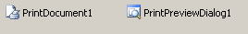
Double click to See
PrintDocument1_PrintPage

When you click on PrintDocument1 on the design screen you are automatically given a subroutine called PrintPage

Private Sub PrintDocument1_PrintPage(ByVal sender As System.Object,
ByVal e As System.Drawing.Printing.PrintPageEventArgs)
Handles PrintDocument1.PrintPage

… … … insert page code here

End Sub

Within this subroutine/procedure you can control the content and the format of the data sent to the printer.

The important parameter is e. The System.Printing.PrintPageEventArgs contain the VB.Net methods for printing (not only text but also shapes and images).

It is used within the program thus:

e.Graphics.DrawString ( String, Font, Brush, X, Y )

e
Graphics | The Graphics class
DrawString | Method within the Graphics class
String | String to be printed
Font | The Font to use
Brush | The colour to use
X | X coordinate to start printing
Y | Y coordinate to start printing

To set the required font:

Dim myFont As New Font("courier new", 12, FontStyle.Regular)

Use the FontHeight to move down the page to print the next line:

FontHeight = myfont.GetHeight(e.Graphics)

The Program Code
Private Sub btnPrintReport_Click(ByVal sender As System.Object.. .. ..) Handles btnPrint.Click
PrintPreviewDialog1.Document = PrintDocument1
PrintPreviewDialog1.ShowDialog()
End Sub
- For the PrintReport button

In the PrintReport button event PrintDocument1 is linked to the PrintPreviewDialog event.
Then the PrintPreviewDialog is called to show the document before the user sends it to the printer.

- For the PrintDocument1-PrintPage procedure

This sub is not connected to a button but is called as the Print document1 to print each page.
Private Sub PrintDocument1_PrintPage
(ByVal sender As System.Object, ByVal e As System.Drawing.Printing.PrintPageEventArgs)
Handles PrintDocument1.PrintPage

Dim myfont As New Font("courier New", 12, FontStyle.Regular)
Dim LineToPrint As String
Dim myFormat As String = "{0,-10}{1,-12}{2,-12}{3,-15}{4,-15}" 'column formats
Dim x As Integer = 50
Dim y As Integer = 50 'x & y are line coordinates
Dim FontHeight As Integer
Dim MaxLinesPerPage As Integer = 30
Dim LinesOnPage As Integer = 0
Static RecNo As Integer 'static to keep count for multiple pages

Fontheight = myfont.GetHeight(e.Graphics)
'Page Title
e.Graphics.DrawString("The Contents of Student File", myfont, Brushes.Black, x, y)
y = y + Fontheight
e.Graphics.DrawString("", myfont, Brushes.Black, x, y) ' a blank line
y = y + Fontheight
'Column Headings
LineToPrint = String.Format(myFormat, "Code", "FirstName", "LastName", "Address", "Phone")
e.Graphics.DrawString(LineToPrint, myfont, Brushes.Black, x, y)
y = y + Fontheight
LinesOnPage = 3
' Read through the file & print one record per line
While Not EOF(1)
RecNo = RecNo + 1
FileGet(1, StudentRecord, RecNo) 'reads record from file
LinesOnPage = LinesOnPage + 1

LineToPrint = String.Format(myFormat, StudentRecord.code, StudentRecord.FirstName, _
StudentRecord.LastName, StudentRecord.Address, _
StudentRecord.Phone)
e.Graphics.DrawString(LineToPrint, myfont, Brushes.Black, x, y)
y = y + FontHeight
'page break at 30 lines
If LinesOnPage < MaxLinesPerPage Then
e.HasMorePages = False
Else
e.HasMorePages = True 'start new page
Exit While 'to ensure a new page is started
End If
End While
End Sub

Run the program to test the appearance of Print Preview. See typical screenshot over page.
Note don’t forget to add records to the student file.

This is a screen shot for the program
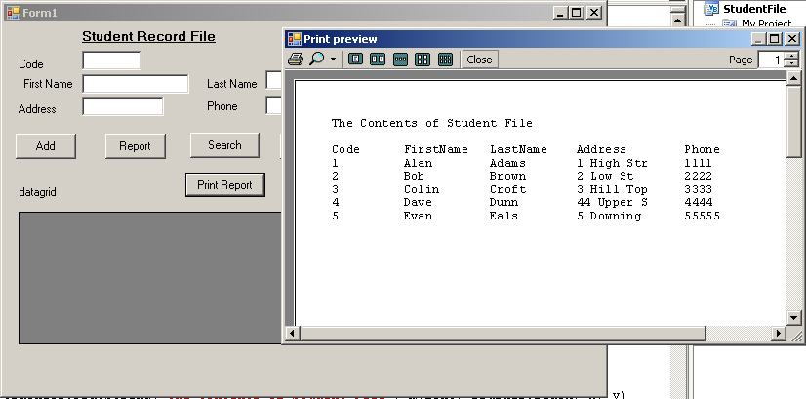

To send the report to the printer the user would click on the printer icon in the Print Preview window.

Exercise

1) Change the size and font of the Title.
2) Add today’s date at the top of the report.
3) Change the font of the column headings to bold.

High Flyers
4) Write a program to print the contents of Bigfile.dat
This file has 100 records.
Print the report 30 to a page (how many pages do you expect?).
The record structure is as follows:
Code 6 characters
Title 4 characters
FirstName 12 characters
LastName 12 characters
Add1 20 Characters
Add2 20 Characters
Add3 15 characters
TelNo 12 characters

