VB Net Debugging

Introduction
A bug is some sort of error in the code which can prevent your program from running properly. When. you write a substantial program always assume that it contains bugs. When you discover a bug you may or may not know how your code has caused it. Debugging is about finding these causes. Visual Basic has a variety of debugging tools, which are discussed here. The later part of the chapter looks at how your code might handle run-time errors, for which the normal process of debugging not relevant.

It makes sense to know about Visual Basic's debugging tools reasonably soon after beginning the language. Handling run-time errors in code is a more advanced topic.

Types of error
There are three types of error:

Syntax error | A syntax error is a mistake in the grammar of Visual Basic. Examples include misspelling keywords (e.g. Lop rather than Loop), forgetting to write a period (.) between a control's name and its property and so on. They are usually simple to fix since the compiler can pick them out for you
Run-time error | A run-time error causes the program to stop working. An example was shown in figure 3.5, where trying to store too large a number into a Short variable caused overflow.
Logic or semantic error | A logic error results from a mistake in the logic of your code. Examples are using the wrong logical operators (AND/OR) in loop conditions or assigning an incorrect value to a variable. It is usually the hardest type of error to track down.

The topic of debugging in this chapter is not concerned with syntax or run-time errors, but with tracking down logic errors. The topic of error handling is concerned with run-time errors so that your program won't crash.

The three program modes
At any time a given program is in one of three modes - design mode, run mode or break mode. Every program you have written has used the design and run modes. If your program produces a run-time error it automatically invokes break mode. You can also get into this mode by clicking the Break button. You can then hover the cursor over any variable and see its current value.

Visual Basic's Debug toolbar and menu
The Debug toolbar and menu are shown below. You'll be using several of these items in this exercise. To get the toolbar select View/Toolbars/Debug from the main menu.

Stepping through code
The Debug toolbar has three options, and the Debug menu two of these three options, for stepping through code - executing it one line at a time. The two options they both share are the most useful:

Step Into Runs the current line of code. If this line calls a general procedure this procedure is entered.
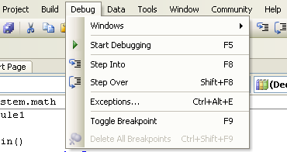
Step Over Runs the current line, but if this is a general procedure call the procedure is executed without stepping through its code.

Using Breakpoints
A breakpoint is a place in the code where the program will temporarily stop. You can set as many of these as you like. When the program stops at a breakpoint you can examine the contents of variables and expressions in the Watch window or in the Immediate window. The programs below shows how to use the Watch window the Immediate window.

Watches
A watch allows you to see the value of a variable or expression as the program runs. As you step through the code this value is displayed in the Watch window. You can only add a watch when the program is in break mode.

PROGRAM: Breakpoints, setting Watches and stepping through code
Specification Demonstrate how to set a breakpoint, set watches on variables and expressions, and how to step through code.

1 . Open a new project. Place a list box on the form and name it lstDisplay.
2. Type the following into the form's Load Event procedure:

Dim Number, Counter As Integer
Number = 2
For Counter = 1 To 10
lstDisplay.Items.Add("2 to the power " & Counter & " is " & Number)
Number = Number * 2
Next Counter

3. Run the program and confirm that it keeps doubling the current number as shown below.
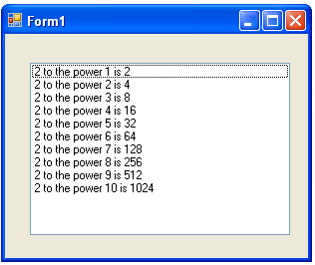

4. To set a watch on a variable we must be in break mode. One way of getting into this mode is to set a breakpoint somewhere in the program. Click in the Margin Indicator bar to the left of Number = 2 as shownbelow. The line of code will be highlighted in brown and a circle will appear next to it in the bar.
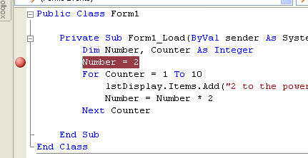

5. Run the program. Execution will stop at the breakpoint, which will now be highlighted in yellow.
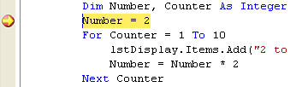

To set a watch on the variable Number, highlight it and right-click, and then select Add Watch.
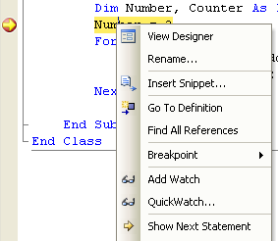

The Watch window will appear at the bottom of the screen. The current value of Number is shown as 0 because the breakpoint line code, which sets it to 2, has not yet been executed.
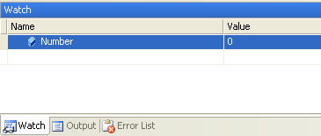

6 You can also put watches on expressions. In the Watch window add another watch as shown below. Type in
Number > 500 and press Enter. We want to know when Number holds a vale. greater than 500. At the moment the expression is False.
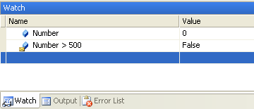

7. Now we are going to execute the code line by line and see what happens in the Watch window. you can step through the code either by using the F8 key, clicking the Step Into icon on the Debug toolbar, or selecting the Step Into item from the Debug menu. Press the F8 key once. The start of the For.. .Next loop is now highlighted and the value of Number is now 2 in the Watch window.
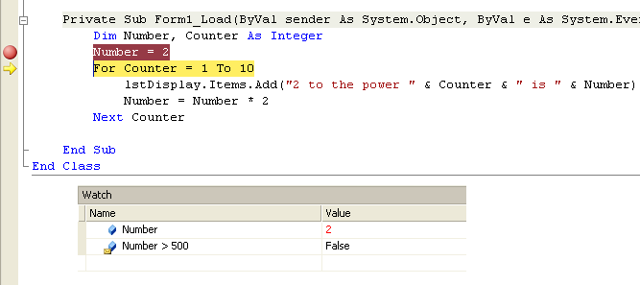

8. Press the F8 key three more times and the value of Number will be doubled to 4. Keep pressing this key until its value becomes 512. At this point the expression in the Watch window is True.

9. Select Debug/Stop Debugging or click Stop Debugging on the Debug toolbar to stop the program. Remove the breakpoint by clicking on the circle in the Margin Indicator bar.

The Immediate Window
The Immediate window lets you do a variety of things such as look at and change the contents variables. As with the Watch window these can only be done in break mode.

PROGRAM: The Immediate Window
Specification : Demonstrate the use of the Immediate Window

This is a simple program that asks the user to enter a product's unit price and the quantity bought. If the total price exceeds £200 there is a 10% discount. It outputs the total price after discount.
1 . Open a new project and type the following into the form's Load event procedure:

Dim Quantity As Short
Dim Price, Discount, TotalPrice As Decimal
Price = InputBox("Enter price")
Quantity = InputBox("Enter quantity")
If Price * Quantity > 200 Then
Discount = Price * Quantity * 0.1 'discount is 10%
End If
TotalPrice = Price * Quantity - Discount
MsgBox("Total price is " & Format(TotalPrice, "Currency"))

2 Run the program to check that it works.

3 Comment out the two lines that use input boxes to get the data from the user. Place a breakpoint on the line with the If condition.

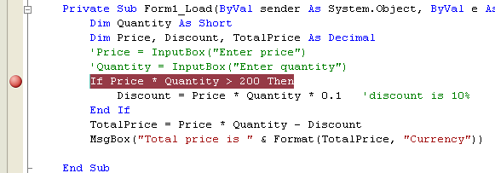

4 Run the program so that it stops at the breakpoint. Select Debug/Windows/Immediate from the main menu to get the immediate window.

5 In the Immediate window set the values of Price and Quantity as shown below. Press Enter after each line.

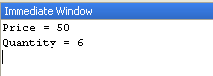

6. Press the F8 key twice to step through the code to the end of the If statement.

In the Immediate window display the value of the variable Discount by typing in ?Discount and pressing Enter. The result is shown below. The discount is 30 (10% of 50 x 6). The D after the 30 indicates that the decimal numbering system is used.

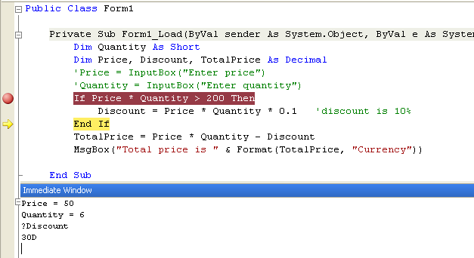

.

7. Remove the breakpoint and stop debugging the program (see step 9 of Program above).

The Debug class
Visual Basic .NET supplies the Debug class to help you debug a program directly from the code. In the Program on page 2- if we had written a Debug.WriteLine immediately after the For.. .Next loop

Debug.WriteLine("The finishing value of Number is 11” & Number)

the Output window would display the value 2048 (since Number would be doubled from 1024 at the end of the loop but not displayed), as shown below. You will have seen this window many times before when your program has finished running and you are brought back to design mode. If it is not visible you can get it by selecting View/Other Windows/Output window.



