Testing- Test Plan & Test Results

This example uses the screen below

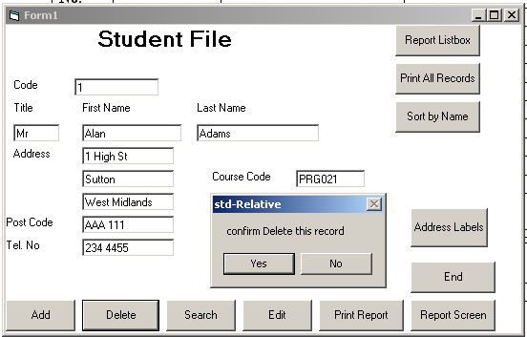
Student File
--------------

Code……….. : 1
Title……….. : Mr
First Name… : Alan
Last Name… : Adams
Address …… : 1 High St
Sutton
West Midlands
Post Code … : AAA 111
Tel No……… : 234 4455

Enrolment
Course Code…: PRG021

Test Data

Design of test data at this stage enables a clearer understanding of what the program is to produce. To design test data later would be influenced by the code written.

Test data must be designed to test every aspect of the program requirements/ objectives set out earlier.

Test Plan

Normal Data is typical of what may be entered into the program.

Normal Test Plan

Student Screen
Test  No. | Test data | Purpose | Expected Result | Check
1 | 1 | Student Code | Accepted
2 | Mr | Title | Accepted
3 | Alan | First Name | Accepted
4 | Adams | Last Name | Accepted
5 | 1 High St | Address line 1 | Accepted
6 | Sutton | Address line 2 | Accepted
7 | West Midlands | Address line 3 | Accepted
8 | AAA 111 | Post Code | Accepted
9 | 234 4455 | Telephone number | Accepted
10 | PRG021 | Course code | Accepted
11 | Select Add | Test Add option. | Record is added to student file
12 | Select search.  Student code as 1 | Test search option | Record 1 displayed  (Alan Adams record)
13 | Select Delete button.  Student code as 1 | Test delete option | Confirm delete message displayed. Record 1 deleted
14 | Select Yes button | Test confirm deletion of record- Yes | Record 1 deleted
15 | Select No button | Test confirm deletion of record- No | No action taken. Record 1 remains on file.

Explained

Test 1 to 10 use typical data that may be expected to be entered in the program.
Test 11 will test the button that adds the test data (Alan Adams information) to the database.
Test 12 tests the search button. With Test Data for Student Code as 1- expected result is that Alan Adams information will be displayed on the screen.
Test 13 tests the delete button. With Test Data for Student Code as 1- expected result is that Alan Adams information will be displayed on the screen.
Test 14 & 15 test the confirm delete option box. Both Yes & No must be tested!

Extreme Data is the highest & lowest values that the program will accept.

Extreme Test Plan

Student Screen
Test  No. | Test data | Purpose | Expected Result | Check
1 | 1 | Lowest value accepted for Student Code | Accepted
2 | 9999 | Highest value accepted for Student Code | Accepted

Explained
Test 1 is the lowest acceptable value for a student code in this program.
Test 2 is the highest acceptable value for a student code in this program

Erroneous Data is data that will cause errors or error messages within the program.
- Erroneous Test Plan

Student Screen
Test  No. | Test data | Purpose | Expected Result | Check
1 | blank | Empty Student Code | Error Message
2 | xxx | Invalid Title | Error Message
3 | X34 5566 | Invalid telephone number | Error Message
4 | Xxxxxx | Invalid course code | Error Message

Explained
Test 1 states what is expected if the Student Code input box is empty when the user selects a button. This test could be more specific and state what the error message would be.
Test 2 states what is expected if the Title input box does not contain an acceptable value (i.e. Mr., Mrs, Miss, etc.)when the user selects a button.
Test 3 states what is expected if the Tel No. input box does not contain an acceptable value when the user selects a button.
Test 4 states what is expected if the Course Code input box does not contain an acceptable value when the user selects a button.

Test Results

Test Results must reference the Test Plan. In the Test Plan each test is numbered and the results are numbered to reflect each test from the plan.

- Normal Testing-Results

Test 1 - 11
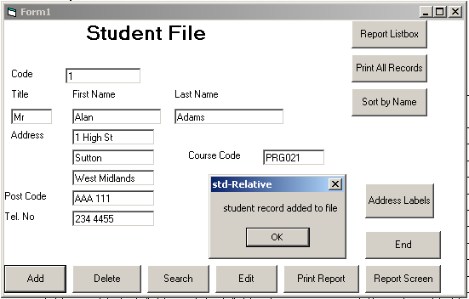

Test 12
Test Search Option - Student Code set to 1
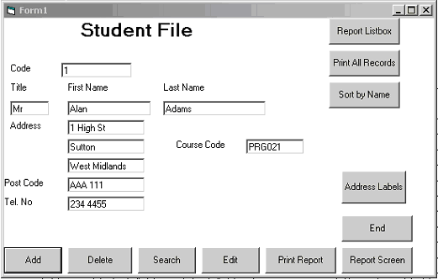
Test 13
Test Delete option-Search Code set to 1
Confirm deletion

Test 14
Select yes -Record deleted
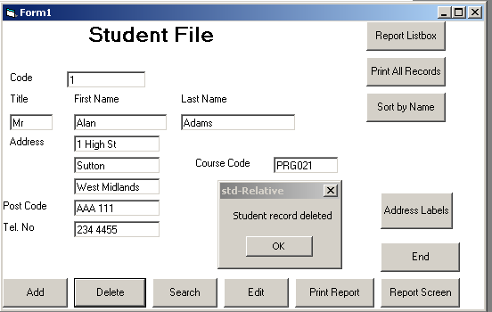

Test 15
Select No- No action taken

- Extreme Testing - Results

A screen is shown for each test in the Extreme Test Plan

- Erroneous Testing -Results

A screen is shown for each test in the Erroneous Test Plan

