The Fundamental Principles of Interface Design

For most HCI specialists, the design of an interface is a cross between tackling the technical challenges and understanding the users’ needs.
Most elements of interface design start by focusing on the visual aspect – what users perceive when they use a computer system.

2.1 Perception
The use of colour is a vital aspect of any interface design.

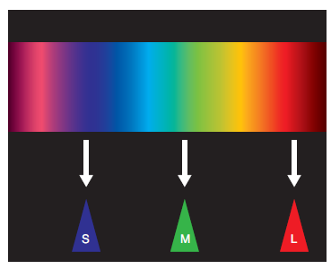
Trichromatic means having or existing in three different phases of colour (Tri =
three, chromatic = colour). Humans have a trichromatic system.
In simple terms the eye’s retina contains
three receptors (often called ‘cones’) which are good at recognising certain phases in the colour spectrum (usually blue, green and red). Blue is the short (S) wavelength, green is the medium (M) wavelength and red is the long (L) wavelength.

By combining different information from
each cone (based on the intensity of the
colour phase it is sensing), the brain can
‘blend’ these to perceive any colour in the visible spectrum.

The ‘pop-out’ effect
The brain is capable of perceiving elements of an image that pop out due to their differences in size, rotation and (most often) colour. The effect is to simply grab the user’s attention.
The following examples demonstrate some typical pop-out effects:

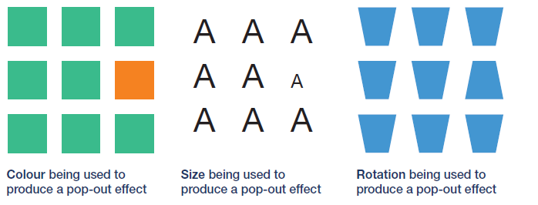

Colour pop-out is often used to highlight selected menu options, alerts and input fields. The pop-out
effect is often referred to as visual salience.

Exercise
Examine the following blocks of characters; which one has the best pop-out effect?

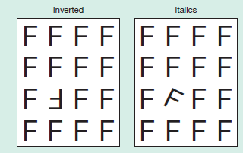

Geons
Biederman’s theory of structured object perception suggests that our brain breaks down complex
objects into simple geometric shapes in order to recognise them; these ‘building blocks’ are called
‘geons’.

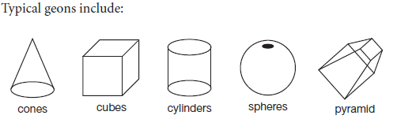

The following examples demonstrate breaking down complex objects into simple geons:
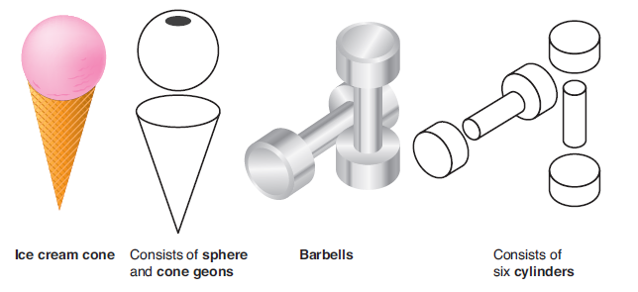

Pattern perception
Pattern perception is part of the Gestalt school of psychology, as written about byWesheimer, Koffka and Kohler in the 1930s. A ‘gestalt’ (old German) is a pattern of elements that is so tightly bound together to form a whole that it can’t be described as just a sum of its parts.

Human beings recognise visual patterns in many things, even tending to invent them where none exist (e.g. seeing different shapes in clouds). If we can understand the principles of layout that involve visual pattern perception, it should be possible to incorporate these ideas into our interface designs.
Common terms we need to be aware of include:

Proximity
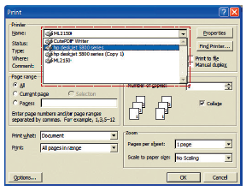
Visual elements that are physically close together (in proximity) are considered to be grouped.

In this example the Windows Print dialogue is indicating possible printers from which we can choose. We know this is a choice because they are listed together.

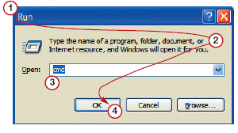

Continuity
Continuity describes the logical flow from one element to another. Where the flow makes sense and is artistically pleasing, it forms good continuity. If the ‘line’ is confused or ‘jumpy’ this forms bad continuity.

In the example above, the Windows Run dialogue uses a logical flow to take the user step-bystep through its interface:

1 names the process;
2 describes what user should do;
3 gives user a choice to enter the command;
4 allows user to confirm acceptance (or cancel).
Notice the flow is top-to-bottom, left-to-right just like reading a book.

Symmetry
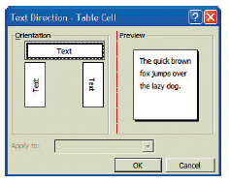
Elements that form symmetrical patterns are more easily perceived as a group.
To form symmetry the elements must be seen on either side of a possible axis of rotation (vertical or horizontal).

In the example shown, the dialogue is grouped around a symmetrical axis running vertically through the form.

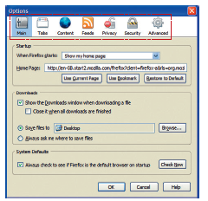

Similarity
Objects that are similar (but not exactly the same) are more easily perceived.

In the example shown Firefox’s options
are all shown in a consistent fashion – similarly styled icons with a text label underneath. Because of this layout, the user knows that these are all choices that can be selected.

Common groupings
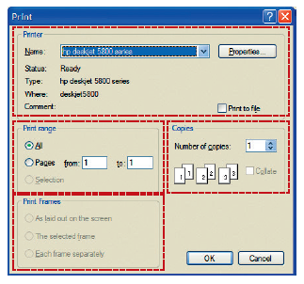
Groups of elements that may be treated as a single
whole are more easily perceived.
If the elements are clearly grouped together by some kind of boundary they are also seen to be a common region.

As can be seen, the Firefox Print
dialogue has four common regions (‘Printer’, ‘Print
range’, ‘Copies’ and ‘Print Frames’).

The use of a framing device clearly separates each
common region and collects together the user interface elements that form it.

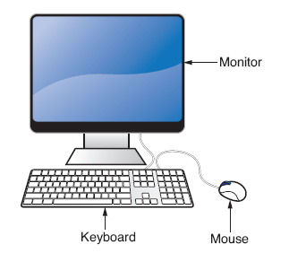

Connectedness
Usually involves the use of lines which may connect elements together, e.g. a label to a picture.

Specialist Requirement

Outside of the detrimental effects of the normal aging process, it must always be remembered that potential users of a computer system may have disabilities that make traditional user interfaces difficult to use.
In these cases it is necessary to adapt interfaces and devices to accommodate users with physical or cognitive challenges. This is often referred to as using assistive technology (AT).

Visual disabilities(e.g. blindness or colour blindness)
Screen-reading software for blindness JAWS (Jobs Access With Speech) colour blindness
http://www.freedomscientific.com/fs_products/JAWS_HQ.asp
Colour cueing and high contrast for colour blindness.
Colour blindness (usually red/green but blue/yellow also exists) affects between eight and ten per cent of the male population. Rather than relying on colour coding alone to group elements or stress importance, use colour cueing (e.g. using other visual indicators such as underline).

High contrast display settings also work well.
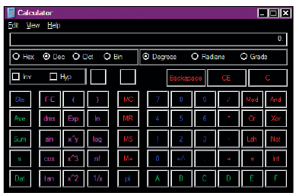

Websites often employ cascading style sheets (CSS) which permit sitewide formatting of content. Such technology can be used to let the user select their personal colour preferences.

Text-to-speech systems are also popular solutions.

Physical disabilities (e.g. motor disabilities)
Adapted input devices such as keyboards that use head/mouth e.g. motor disabilities sticks.
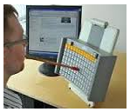

http://www.maltron.com/images/products/msk-on-mod-solid-arm-1-450.jpg

Hearing impairments (e.g. deafness hard of hearing)
The most common solutions to hearing impairments often involve the generation of additional visual stimuli to replace interface sounds (e.g. warning beeps, confirmation tones) that the user can’t hear.

However, this causes its own problems as it can lead to an overload of visual information that makes the user interface difficult to comprehend.

Speech disabilities
This mainly affects users who have to use some form of voice recognition software in order to use a computer system. Generally their disability may affect the loudness or clarity of their voice.

The obvious solution is to provide an alternative input mechanism (e.g. a keyboard).
Telephone banking systems often use voice-recognition systems to validate bank account numbers or telephone numbers. When this isn’t possible, the user should have the ability to input the information in another manner, e.g. using the telephone keypad itself.

Cognitive and neurological disabilities
(dyslexia and dyscalculia, attention deficit disorder (ADD)

Dyslexia (difficulty with written words) and Dyscalculia (difficulty with neurological disabilities numbers and numeric calculations) make it difficult for some users to interpret information which is presented in a single format. In such case it is advisable to present the same information in a number of different formats, i.e. as text, as spoken words, as an animation. Each format will then reinforce the understanding of the other.

Users with learning barriers such as ADD need user interfaces that are simple, linear and without distractions (such as unnecessary links or flashing animations) in order to keep them focused.

Memory impairments
Short- or long-term memory loss may affect a user’s ability to operate a computer system reliably. A well-designed HCI solution can help by making navigation and usage consistent; this can be achieved by keeping dialogues, screen layout and menu systems the same throughout. Colour-coded keyboards or keyboard overlays can also prove useful.

